Name: Amol Shivaji Tambekar Roll No:54 Batch:3

First you need to download couch dbfrom thegiven link for Windows operating systems.

Step 1- After downloading, run setup file. Click on Next tab
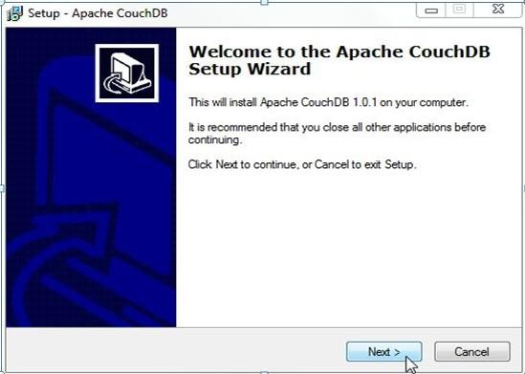

Step 2 - Accept agreement and then click Next
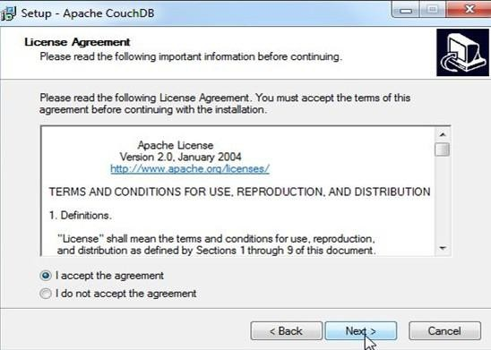

Step 3- Select path where you want to install Couchdb and then click Next

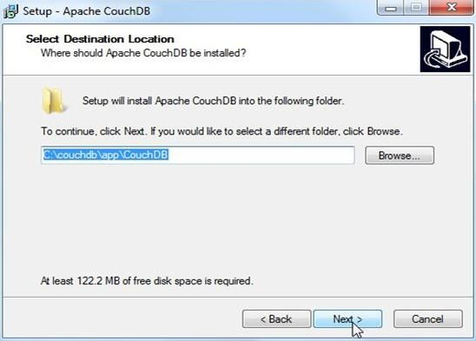

Step 4 - Select additional tasks and then click Next
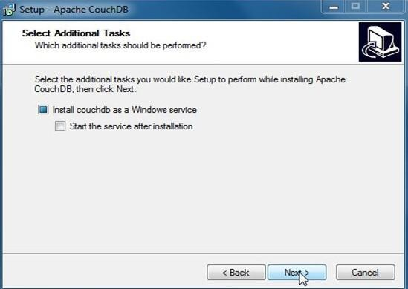

Step 5 - Click on Install
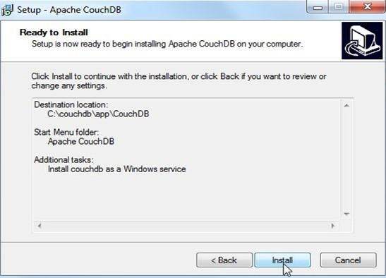

Step 6 - After install go to Computer right click on it and select Manage.
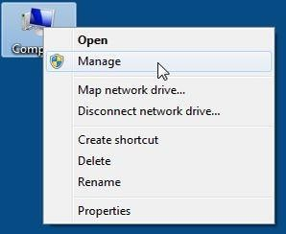

Step 7 - Click Services and Applications.
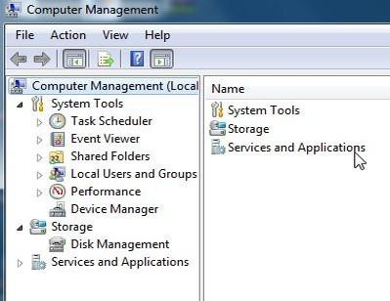

Step 8 - Click on Services.

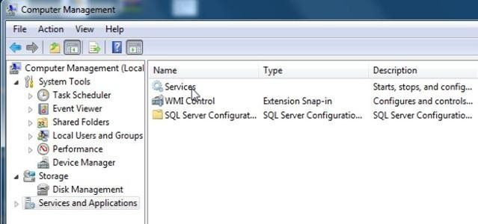

Step 9 - Right click on Apache CouchDB and then click on Start.

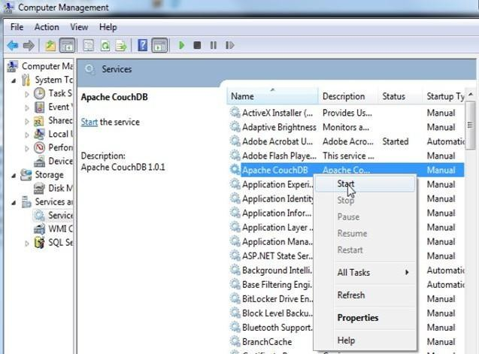

Step 10 - After selecting start go to start menu and select all program, click on Apache CouchDB and then click on Futon (Couch DB web interface). See given below figure.
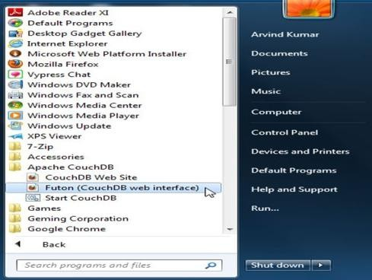

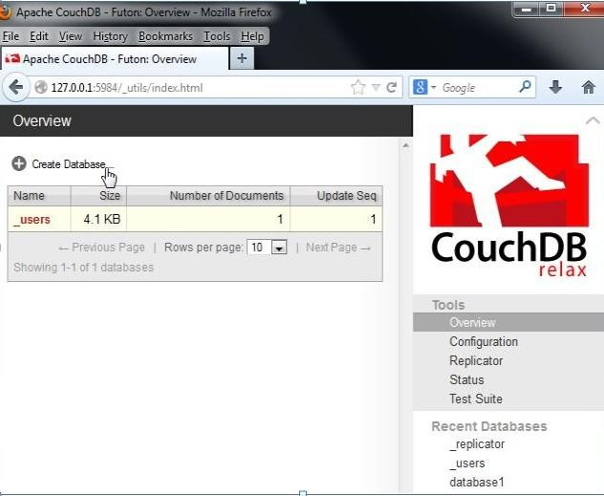
Step 11 - Finally CouchDB start

